SAR meeting Minutes
East Fork Trinity
Chapter No. 47
Regular Meeting 10-14-21
Soulman’s BBQ
7:00 PM

Call to Order - 6:59

Invocation - Jason Gray

Pledge to the American Flag - Stuart O’Connor

Pledge to the Texas Flag - Gary Lovell

SAR Affirmation - Leslie Anderson

Greet Members and Guests - Michael Goode
25 In attendance

Program “Firearms of the American Revolution” by Michael Philippi
NRA instructor through BSA in muzzle loaders and other small arms. He’s was a member of the Colorado Springs Muzzle loader club and initially said he would never own a flintlock. Little did he know he would Move to Texas and meet Ben Roper in the Dallas Muzzle Loading Gun Club. Michael shoots competitively with a .50 caliber Hawkins. Flag Retirement ceremony is the link to him joining SAR. His Patriot is Boaz Walter. In 2018 a genealogist was able to prove generations 5,6,7,8,and 9 all he needed was the first 4 generations for his connection.
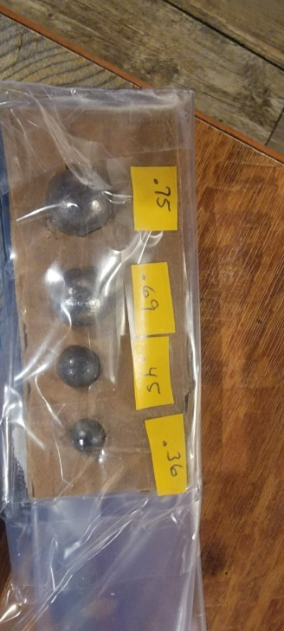

Muskets
His prop is a 1776 Charleville musket. Ben Franklin went to France who allied with us and gave us 25000 Charleville muskets. It is designed for .64 balls. They were not hunting weapons. The Brown Bess the British used were.75 caliber. A “good infantrymen” could shoot 3 rounds a minute. They were “accurate” to 50 yards based on the powder quality of the day. Using powder produced today they are accurate to 100 yards. These muskets were not designed for accuracy they were designed to throw out a ton of lead.
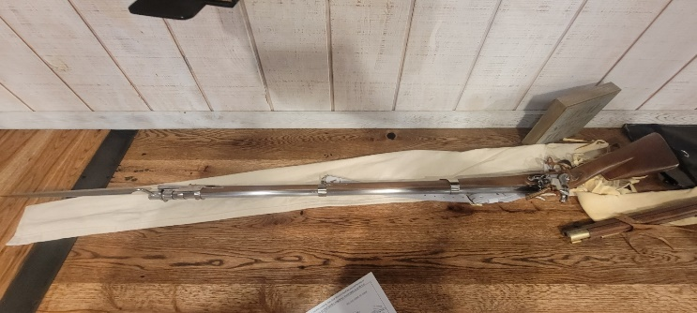

Shooting
They were flamethrowers because of the muzzle flash when they expelled burning powder.
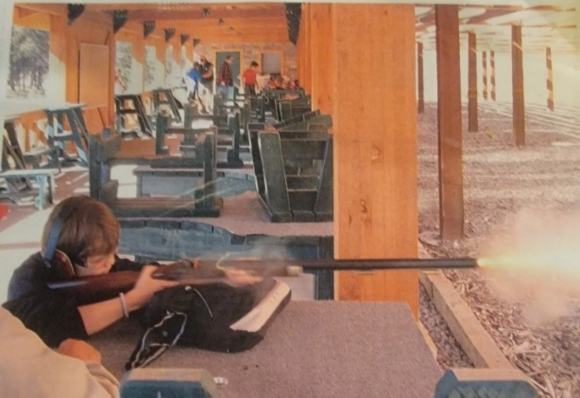

Rifles
Pennsylvania long rifle weighs 9.5 lbs. it has a 39 inch barrel. Militia used the rifles. 1705 the German immigrant family named Mueller and another family were the first to make rifles in the US. The long Rifles or squirrel guns as they were called due to the smaller ball they fired, were longer because they needed the extra length for increased accuracy due to powder burn time. A good militiaman could reach out 200 yards with a .36 caliber. The militiamen would fight a guerrilla war and snipe British Officers. Generally, the barrels of rifles were 32 inches to 44 inches. Today you have to have rifles over 32 inches custom made. Only 50% of powder ignites and the rest is called fowling. Fowling plus moisture equals rust. Flintlock only uses actual black powder.
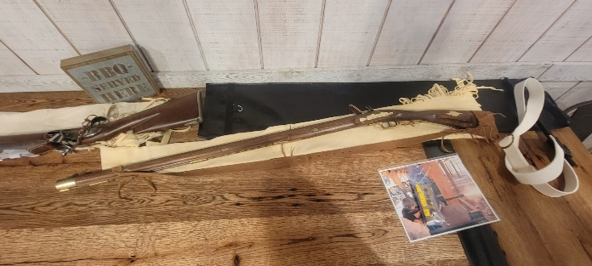

1802 John DuPont came to the us and in 1805 he started his powder company and used the Swiss formula which was the best.

The Dallas Muzzle Loading Club would like to invite any interested Chapter members to their Annual Open Shoot. It will be held on October 23. The open shoot will be held at their 100 yard range. (More information and a Map will be added as attachment.)

Certificate of Appreciation given as a token of thanks.

Approval of September Minutes
1st – David Jackson
2nd - Bob Vickers

New Business
Partners in Patriotism award given to the Chapter at the BOM meeting

Leslie Anderson received
2nd place at BOM for our 2020 yearbook
1st place at BOM for our 2019 yearbook

Flag Certificates given out.

Wreaths across America will be done in December and wreaths can be bought through November 30 2021

Meeting location was discussed, and the intent is to extend through next year for Soulman’s BBQ as meeting location on 2nd Thursday of each month from 6PM to 8PM. Michael Goode will contact the management to continue the agreement.

Inductions
Ken Miller - Patriot - maternal grandmother Samual Pickerel was a drummer throughout the revolution.

Treasurers Report - Michael Goode
Will be sent out with minutes

Color Guard Report - Bob Kubin

Special thank you for all that participated at the Membership table at the State Fair.

Sept 25 Gainesville Medal Of Honor Parade.
39 Color Guard members participated. There were 13 chapters represented and members drove from as far as Conroe and San Antonio. There were 9 members whom were unable to march and rode on a float that was brought courtesy of the McKinney Chapter. This was a National event and we don’t have to wait for a year for this to happen again as the Parade will return to it’s normal Schedule in April 2022. The Bronze Galvez medal was awarded to those who didn’t already have it due to this being a National event.
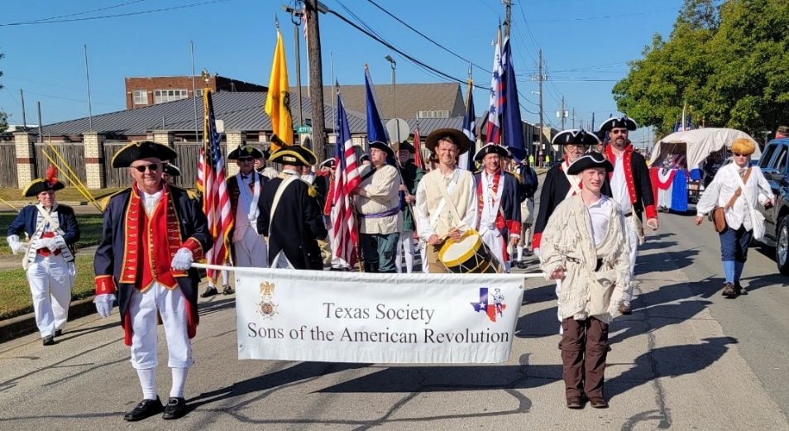

BOM meeting was held last weekend.

Audie Murphy parade in Farmersville was cancelled.

Coming events
(Handout attached)

Bronze Galvez Award Ceremony
One time participation at the Gainesville Medal of Honor Parade which was a National Event enabled Color Guard Members to receive this Award. There were 9 members of the East Fork Trinity Chapter #47 in attendance. Tonight the Bronze Galvez Medal was awarded to 5 Members of the Chapter.
North Texas Consists of 21 chapters. The Bronze Galvez Color Guard medal was presented tonight on behalf of Blair Rudy State Color Guard Commander by Bob Kubin North Texas Color Guard Commander.

Registrar’s Report - David Powell
10 new members this year
5 at national
4 Member family that Walt and Barbara are sponsoring
1 new prospect
5 supplemental thus far and 1 currently at national.
From the State Fair we have 6 new prospects

Ladies Auxiliary - Will have an Raffle for stained glass that will go from the BOM meeting through the annual meeting in 2023. Funds will be used to donate 1 or more household items to the national SAR museum. Tickets are 1 for 5 or 5 for 20. Contact Margaret Anderson Cell 9728391522 or Mla3500@yahoo.com to purchase Raffle tickets (Flyer attached)

Birthdays - Leslie Anderson, Clyde Frith, Brandon Nelson, David Powell, Chase Rediger, Roy Palvadeau

Door Prize Drawing - Bob Vickers

SAR Closing - David Routh

Benediction - Jason Gray

Declaration of Adjournment - 7:47

